Download MySQL Workbench from Google Search

# Introduction

This lab will guide you through the steps to download MySQL Workbench, a unified visual tool for database architects, developers, and DBAs. By the end of this lab, you will have MySQL Workbench installed on your computer.

# Let’s Get started

## Steps to Download MySQL Workbench

### Step 1: Navigate to Google Search

1. Open your web browser.
2. Navigate to <https://www.google.com/search?q=mysql+workbench&rlz=1C1CHBF_enIN1109IN1112&oq=mysql+workbench&gs_lcrp=EgZjaHJvbWUyBggAEEUYOTIGCAEQRRg9MgYIAhBFGD3SAQg0NDkwajBqN6gCALACAA&sourceid=chrome&ie=UTF-8>

### Step 3: Access the MySQL Download Page

1. From the search results, locate the link titled MySQL :: Download. It should be one of the top results.
2. Click on the MySQL :: Download link to navigate to the official MySQL Workbench download page.

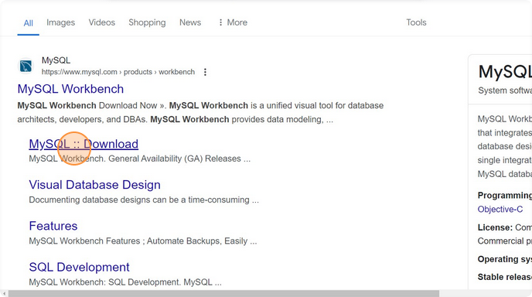

### Step 4: Download MySQL Workbench

1. On the MySQL Workbench download page, you will see various versions of MySQL Workbench available for download.
2. Click on the Download button for the version that matches your operating system (Windows, macOS, Linux).

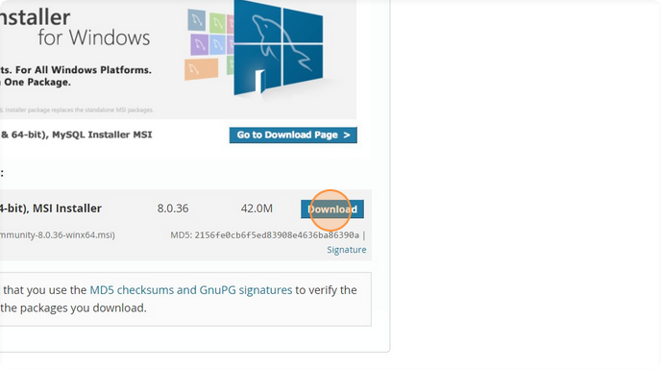

### Step 5: Skip Optional Sign-Up

1. After clicking the download button, you might be prompted to sign up for a MySQL account.
2. Click on No thanks, just start my download to skip the sign-up process and start downloading the installer directly.



**Voila!!** We have successfully completed this exercise.